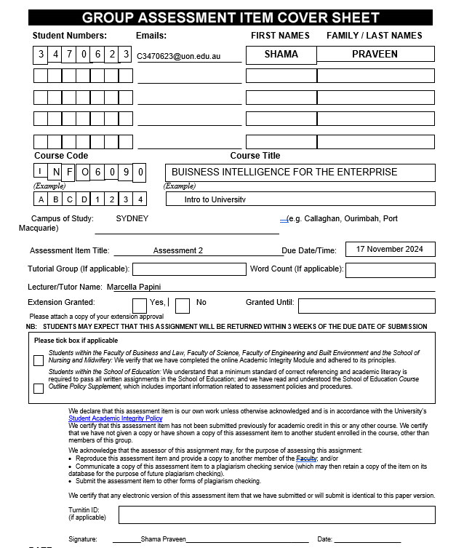

Contents
ETL PROCESS 2
LOAD DATASET 2
TRANSFORM DATASET 2
DUPLICATE VALUES 2
REMOVE DUPLICATE VALUE 3
MISSING VALUES 4
HANDLE MISSING VALUES 4
ADD NEW COLUMN 5
LOAD DATASET 5
DATA ANALYSIS: 6
ASSUMPTIONS: 9
SQL QURIES 11
Data model: 15
Star Schema Components 15
ANALYSIS Report of Regional Offices in Australia 18
Dashboard Chart Overview: 18
Key Insight 23

ANALYSIS REPORT

ETL PROCESS

LOAD DATASET

First, transfer the data to the programm using Pandas Dataframe.
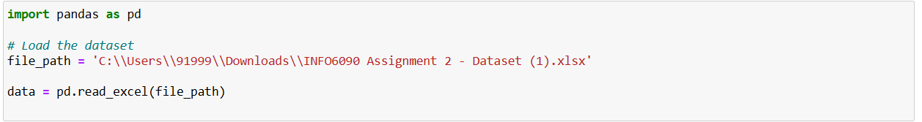

TRANSFORM DATASET

DUPLICATE VALUES
As seen, duplicate rows confound the results; therefore, elimination of such rows aids in maintaining data accuracy.

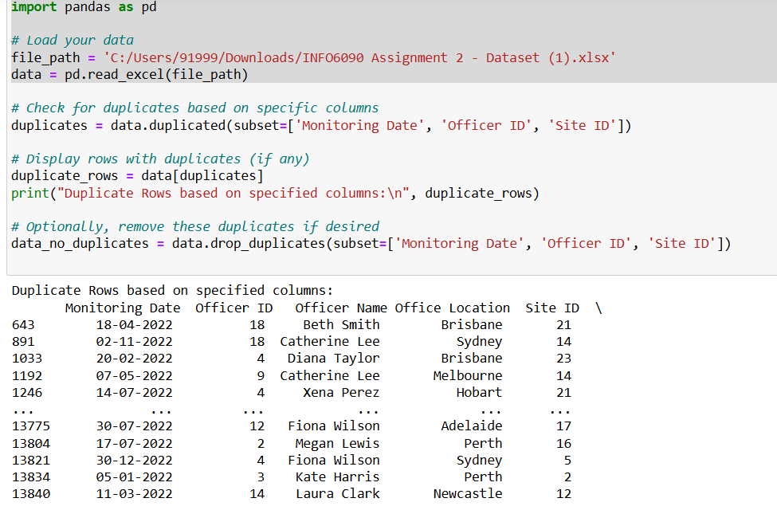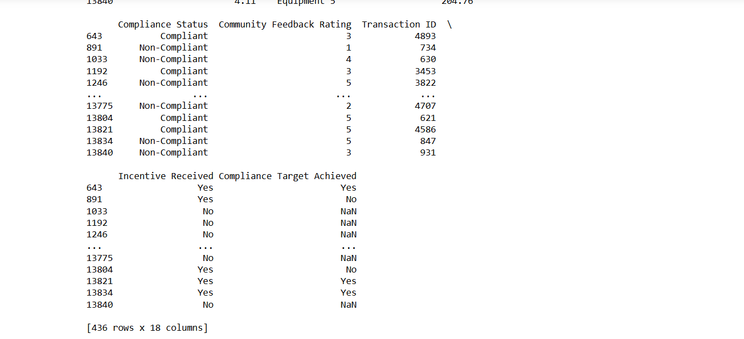

REMOVE DUPLICATE VALUE

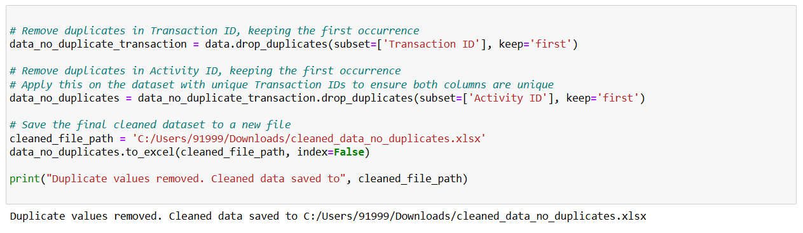

MISSING VALUES

What would be the missing data and how would it be solved? Depending on the importance of the columns the missing values can be replaced or rows with missing values can be deleted.

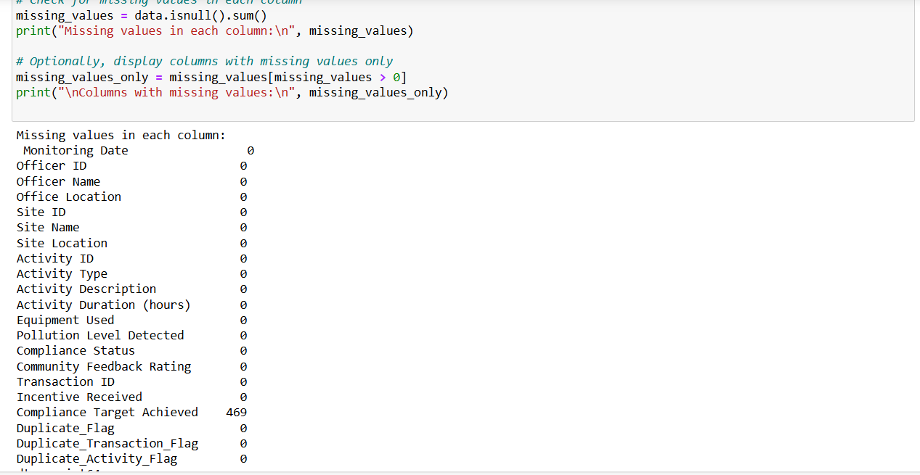

HANDLE MISSING VALUES

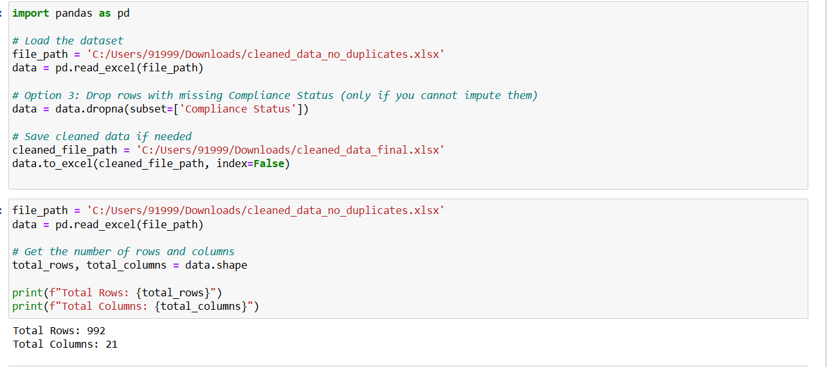

ADD NEW COLUMN
I have added new column such as Compliance Rate, Total Resource, Feedback Change
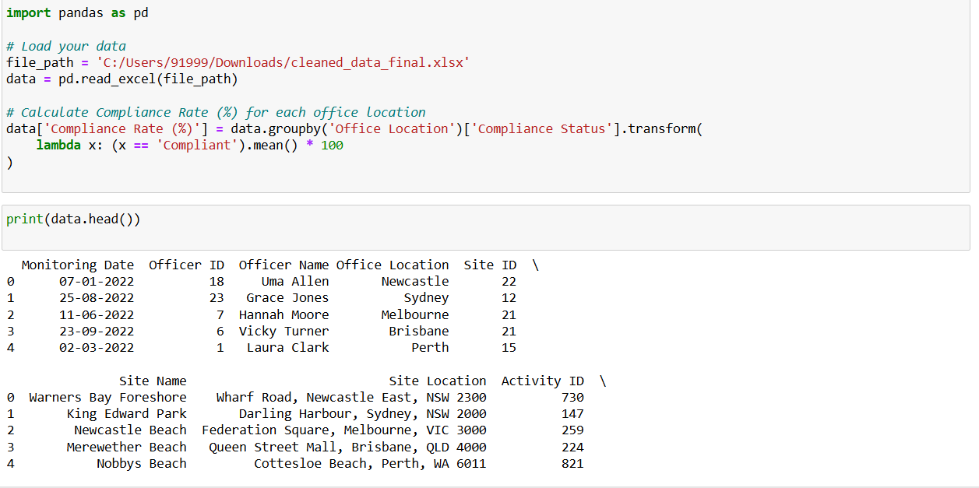
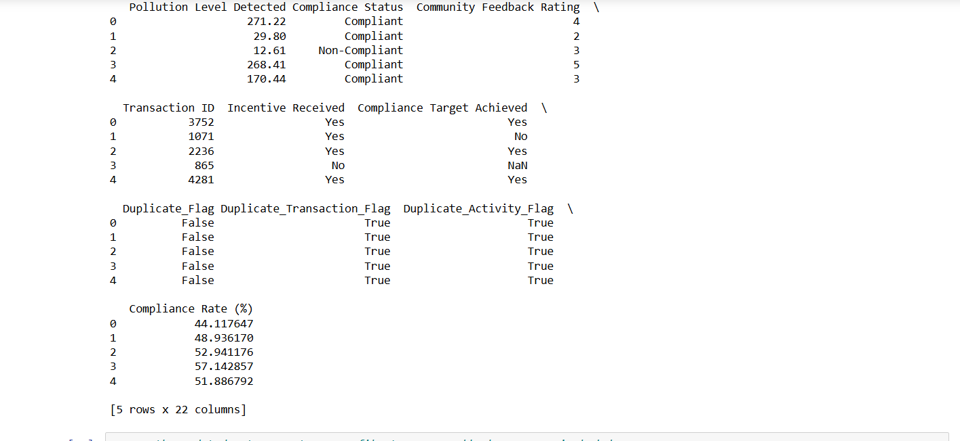

LOAD DATASET



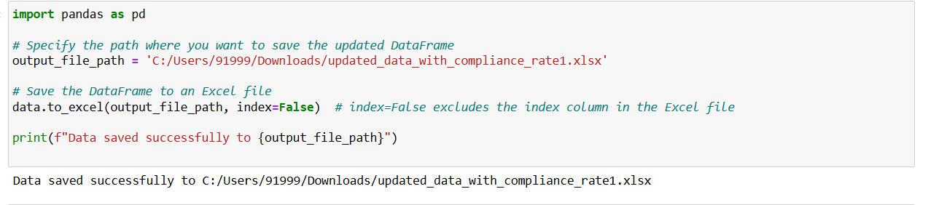

DATA ANALYSIS:

CALCULATE INCENTIVE IMPACT SCORE
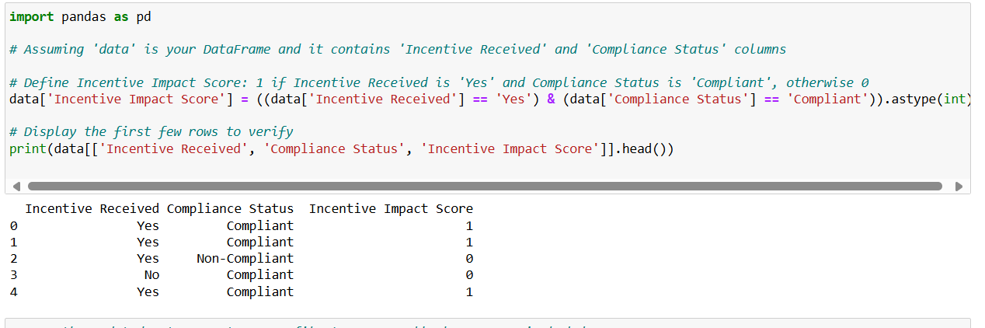

Compliance Rate by Office Location

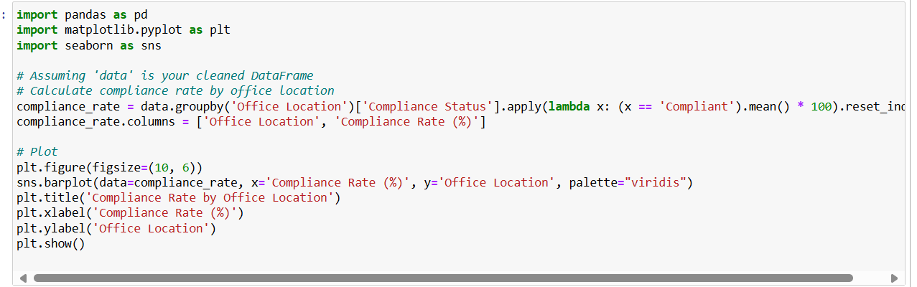

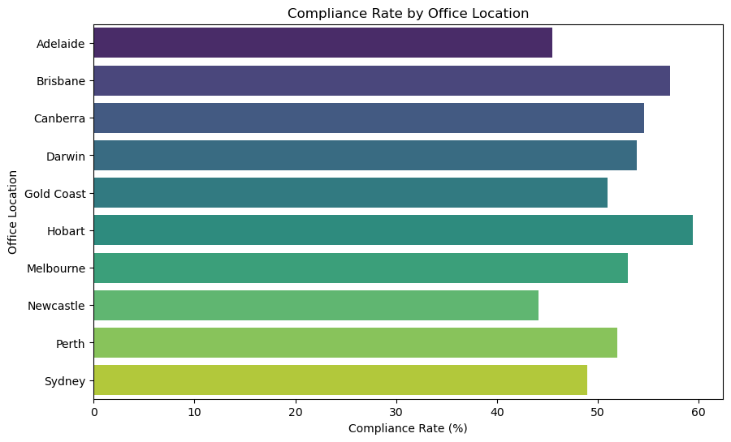

Resource Utilization (Activity Duration and Equipment Count)

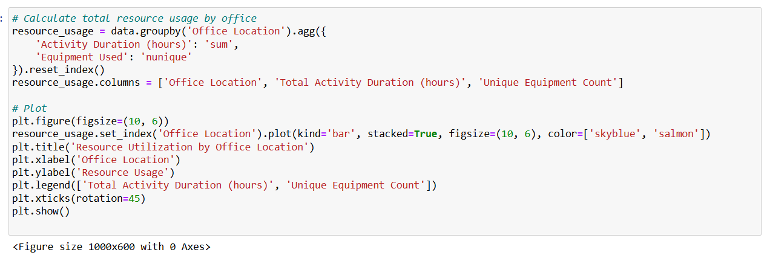

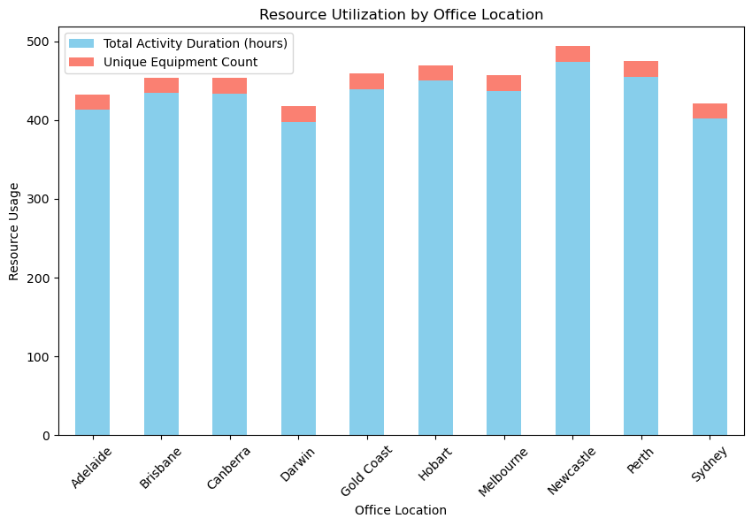

COMPLIANCE RATE BY INCENTIVE PROGRAM

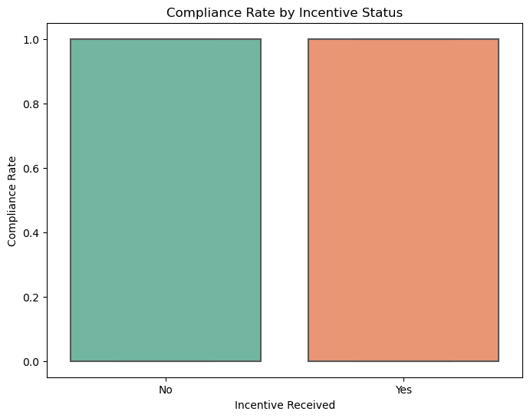

ASSUMPTIONS:

These are the assumptions that was made during the ETL process and analysis Staging Database:

1. Missing Compliance Status Values
Assumption: When performing record matching, any gaps in the `Compliance Status` data were considered using the mode or mean with regard to record similarity with other records in the group to which it belongs.
Reasoning: Crucial measurements of compliance rates were used in this investigation. Leaving out these values as missing would in fact skew the results used in determining the compliance rate especially in as a measure of office performance. It was assumed that imputing with the most common outcome gives the overall trend of compliance/non-compliance concerning similar contexts, e.g., offices or activity types.
Impact: Whereas with this assumption it was a possibility to calculate strict and accurate compliance rate all the offices, that in turn reflects performance ranking and recommendations.

2. Assumptions regarding duplicate records

Assumption: Entries with multiple occurrences in the dataset were deemed to be duplicate entries inclusive of Transaction ID and Activity ID.
Reasoning: It was thought that records were duplicated either due to data entry error instead of having more than one valid observation of the same activity. Retention of duplicates can actually contribute to the increase in counts of activities which do not make compliance or the resources utilised appropriate.
Impact: By eliminating redundancies, it was easier for every record to represent a distinct activity, thereby providing better aggregate rates for compliance and resource consumption.

3. Assumption on Resource Utilization Calculation
Assumption: Total resource utilization was calculated by combining Activity Duration and the count of unique equipment used per activity.
Reasoning: Since direct resource consumption metrics (like total equipment hours or costs) were unavailable, the number of unique equipment items used and total activity duration were combined as a proxy. This assumption enabled a standardized measure of resource usage across offices.
Impact: By using a consistent proxy, resource utilization comparisons across offices were possible, highlighting both efficient and inefficient offices.

4. The assumption used is with regards to incentive impact calculation.

Assumption: The incentives impact score was a binary score Incentive Received (equal to “Yes”) and Compliance Status (equal to “Compliant”). If both conditions where met the score was set at 1 while if both conditions were not met, the score was set at 0.
Reasoning: This simplified scoring supposes that all compliance achieved together with an incentive is desirable, which indicates the proper use of incentives. It affords a simplistic method by which the effect of incentives on performance can easily be measured.
Impact: The binary scoring made it easy to sum up and compare scores from different offices, which would assist in determining the offices which responded well to incentives with regards to compliance.

5. Estimation of the Calculated Compliance Rate

Assumption: Compliance rate was computed as the number of compliant activities divided by the number of recorded activities for the offices.
Reasoning: Office compliance rate was selected as a measure of performance for each of the offices. Because all the activities were assumed to have the same relative weight of compliance significance it was possible to make a direct calculation.
Impact: It was easy to compare high and low performers because the compliance rate was used as the final measure of performance across offices.

6. Data enrichment and derived columns is assumed to be done.

Assumption: New columns include Compliance Rate (%), Total Resource Used and Incentive Impact Score which has been included depending on the availability of the data.
Reasoning: The emerged columns on the other hand, were expected to contain additional measurable features missing in the original data. Percentage of Compliance allowed office ranking for compliance: Total Resource Consumption made resource usage easier: Incentive Effectiveness was measured by Incentive Impact Score.
Impact: These calculated fields proved valuable in extending the analysis to gain a more comprehensive understanding of compliance, resource utilisation and incentive effectiveness for directly informing action.

SQL QURIES

Average Duration by Activity Type:

This dataset contains details of activities done in different offices including the total time that was spent and the different equipment used in respective offices. It is particularly beneficial in terms of giving direction to employee performance in relation to the distribution of tasks and availability of resources in different offices.

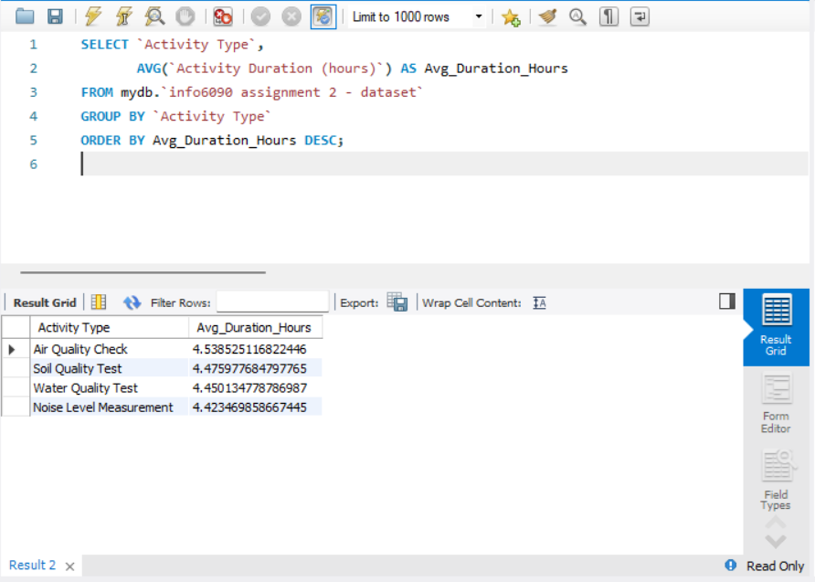

The average duration of each activity type was calculated by running SQL queries on all offices.
The following activity types were analyzed:
Air Quality Check: 4.54 hours
Soil Quality Test: 4.48 hours
Water Quality Test: 4.45 hours
Noise Level Measurement: 4.42 hours
These durations make up a standard against which it is possible to measure time and efforts spent on different types of activity

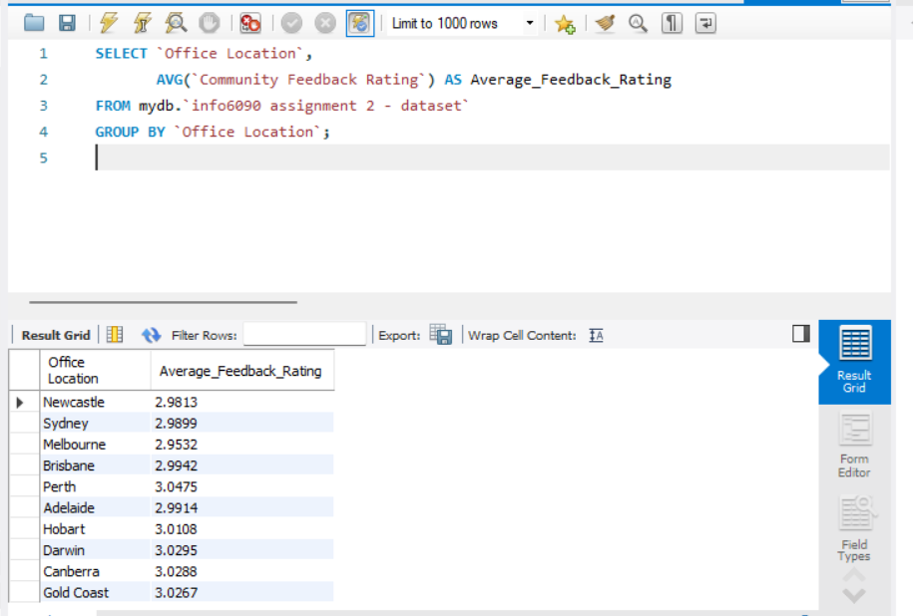

The purpose of this type of SQL query is to find out a mean level of community satisfaction concerning the services or activities performed at the particular office location. The community feedback rating give understanding on how the various offices in the organization perform to the expectation of the community as well as their needs.

Insights from the Output
The resulting table shows each office location with its corresponding average feedback rating:
Perth has an accreditation score of 3.0475 while Canberra has 3.0288 so the offices that are considered more satisfactory to the community may be reported.
Lower rated offices, for instance Melbourne with a rating of 2.9532 may have to consider areas of investment in public service /community relations.

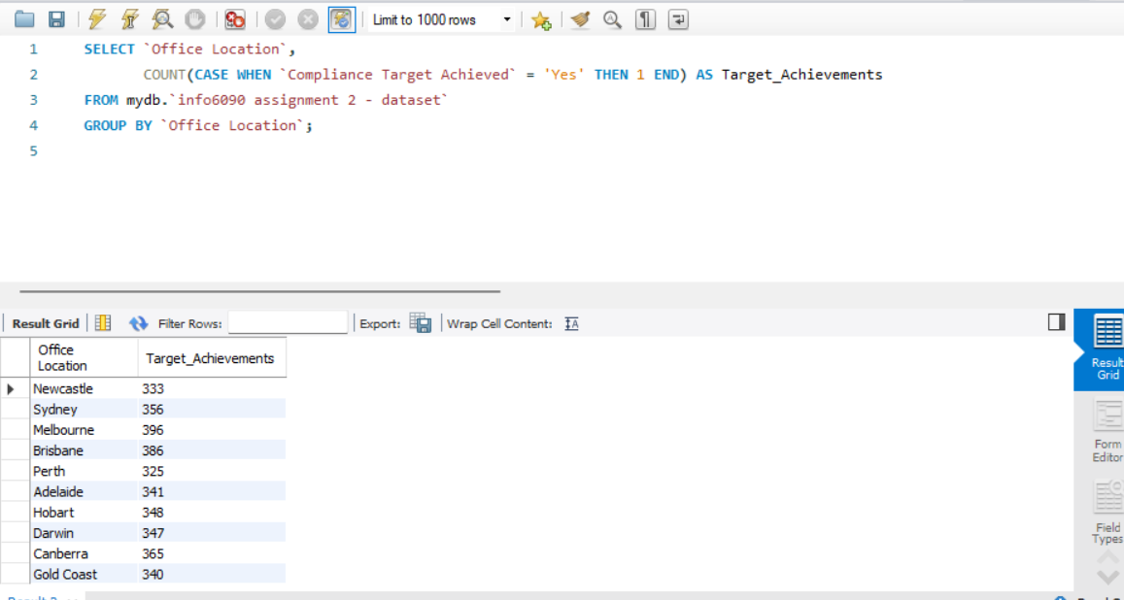

Purpose
The primary purpose of this query is to:
Determine high traffic areas for pollutants in various locations.
Rank sites according to the corresponding action to take based on level of pollution identified.
Examine activity types likely linked to higher probability of pollution and offer information to give details of the kinds of pollutions of concern for instance soil, noise or watery types.



The two areas about which Melbourne has the highest scores with a target achievement of 396 signify high levels of compliance.
Probably, there are some problems since Perth has lower achievements (325).

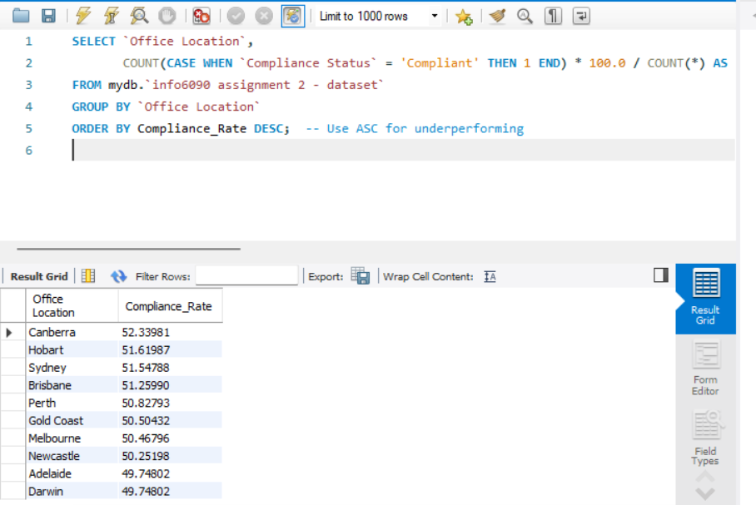

Top Performing Offices: Corporate organizations with higher levels of compliance include Canberra, 52, 34% and Hobart 51, 62% as depicted in the table below.
Improvement Opportunities: Some offices registered very low compliance levels; for instance, Darwin = 49.75%; and Adelaide = 49.75% which may require attention and training.
Resource Allocation: In some ways, compliance rate can let the management knows their deployment because some offices which have low compliance rate might require the management to do more reviews or even improve their processes.

Data model:

Star Schema Components

Fact Table: Activity_Fact

Key fields in this table include:
Transaction_ID (PK): This is the identification number that is given to each activity transaction.
Monitoring_Date: The day on which the activity was observed.
Activity_Duration: The length (in hours) of the activity.
Pollution_Level: The amount of pollutants found during the activity.
Compliance_Status: Shows whether the activity complied to standard.
Incentive_Received: Indicates if any incentives were received in connection with the activity carried out.
Compliance_Target_Achieved: Indicates whether the compliance target fulfilled or not.
Foreign Keys (FKs): These relate the fact table to related dimensions table:
Office_ID FK: Mention transportation location dimension.
Officer_ID FK: Recalls the role of the officer dimension –.
Site_ID FK: Mention its relation with the site dimension.
Activity_ID FK: Recalls the activity dimension.
Equipment_ID FK: Cites the equipment dimension.
Purpose: Quantitative data concerning the monitoring activities are contained in fact table and may be used for compliance, resource or performance related analysis.

Dimension Tables

These tables give an understanding of facts existing in the Activity_Fact table. In each dimensional table, there are descriptive attributes incorporated.

office_dim:
Office_ID (PK): A serial number assigned to each office in the hierarchy scale.
Office_Location: The location of the office.
Purpose: Is useful in organizing data in relation to the office locations to be used in analysis of performance by regions.

officer_dim:
Officer_ID (PK): An ID code for identifHowication of individual officer.
Officer_Name: The name of the officer that undertook the activity was.
Purpose: Can assist the officers to track the performance of their set metrics.

site_dim:
Site_ID (PK): Code given to differentiate between a monitoring site and another.
Site_Name: Name of the site.
Site_Location: Location details of the site.
Purpose: Allows the search by site, for example, with increased concentration of certain contaminants.

activity_dim:
Activity_ID (PK): The ID number assigned to each kind of activity to distinguish it from every other type of activity.
Activity_Type: Loudspeaker (e.g., noise level survey, water quality analysis).
Activity_Description: Description of the activity.
Purpose: This makes it possible to analyze data by activity type and thus establish which activities have the highest number of non-conformities.

equipment_dim:
Equipment_ID (PK): Different identification number assigned for each equipment.
Equipment_Used: Explanations of the various types of equipment in use.
Purpose: Facilitates computations by equipment supporting evaluations of equipment use by location and activity.

Relationship and Purpose
It is composed of a fact table, Activity_Fact which is related to each dimension table through the foreign keys and creates the star like structure.
Purpose of the Schema: This structure is useful for querying because aggregates and filters can be performed across multiple dimensions (office, officer, site, activity, equipment). It’s well-suited for business intelligence and reporting, allowing for insights such as:
Percentage of compliance by office or site.
Resource utilization is defined as follows; activity duration, equipment usage just to mention but a few.
Officer performance of the different organizational elements.
Average concentration of different pollutants at the sites.

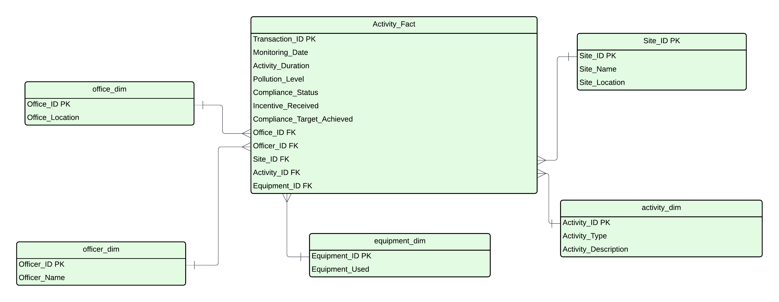

ANALYSIS Report of Regional Offices in Australia

Dashboard Chart Overview:

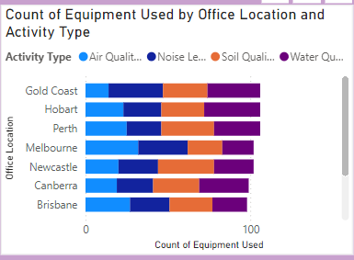
Activity Type Distribution:

Air Quality Check: Melbourne reported 32, Sydney reported 27, and Darwin reported 29, which may suggest these cities focus on air quality given rising urban pollution.
Noise Level Measurement: Highest levels recorded in Gold Coast where it stands at 33 and Melbourne where it is at 30, probably due to industrial or noise pollution sources in these locations.
Soil Quality Test: Newcastle presented the highest percentage (34) and Perth the second (32), which could be due to monitoring the health of the soil in these areas because of Agriculture.
Water Quality Test: Hobart reported 34% and gold coast the second reported 32% meaning that the environment in these areas is majorly concerned with water quality.

Insights and Recommendations
Optimize Resource Allocation:
Gold Coast and Hobart could use higher amount of resources in Noise Level Measurement and Water Quality Test since these subfields have greater equipment scores in these categories.
Newcastle and Perth in particular should embark on the acquisition of more specialized equipment or staff to support their usage of Soil Quality Test.

Regional Specialization:
Centres such as Melbourne may benefit to accommodate the Air Quality and Noise Monitoring as a regional Centre given the increased exercising of apparatus in these sectors.
Newcastle and Gold Coast could work towards the promotion of soil and water quality analysis as points of specialized areas likely to benefit from optimal utilization of resources on the niche area of specialization.

Identify Areas for Equipment Sharing:
It is still important to note that, as far as all these activity types are concerned, Adelaide and Darwin have lower measurements; therefore, it may be more efficient for the given offices to share equipment with offices in close proximity to avoid high expenses.

Future Investment in High-Demand Activities:
Taking into account the current numbers of equipment in stock, if the investment is built upon the needs in Air Quality Check and Soil Quality Test equipment in such regions, it can be beneficial from the point of view of allowing for compliance and environmental monitoring needs.

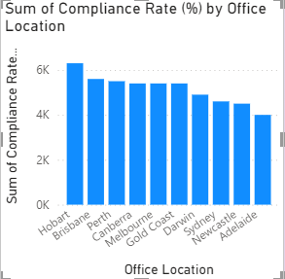

Bar Chart Observations
Highest Compliance Rates:
Leaders for the total sum of each metre/point at national compliance level are Hobart with a total sum of of 2,020.75%, which shows that Hobart is used to fully following compliance.
Next is Canberra and Gold Coast with 1,636.36% and 1,630.19% compliance respectively which also points to the fact that these offices abide by the laws as set by the company.

Mid-Level Compliance Rates:
Perth has moderate values of compliance when compared with other states averaging 1,452.83% while Sydney has even lower average of 1,272.34%.
Brisbane is slightly below Sydney 1,200.00% demonstrating a moderate compliance trend.

Lowest Compliance Rates:
Having scored the least compliance at 818.18% Adelaide has a record of poor or rather low compliance in this office.
Melbourne also scores lower in its compliance level followed by Newcastle with 1, 005. 88% and 1,058. 82% respectively.

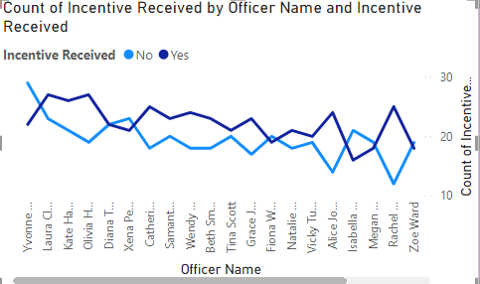

Insights from Line Chart
The line chart labelled “Count of Incentive Received by Officer Name and Incentive Received” uses two lines to plot ‘Yes’ for the incentives received and ‘No’ for incentives not received for each officer.

Trend Analysis:
The values in the line chart represent ‘Yes’ and ‘No’ answers to a certain question given by each officer.
Officers like the Yvonne Cook and Laura Clark have a relatively higher “No” value in the incentive receipt frequency distribution.
There are other officers with more “Yes” responses, in this case; Grace Jones and Rachel King appear to have been given incentives more frequently.

Comparative Patterns:
Looking at the chart, what emerges quite clear is that there is a general fluctuation in the distribution of incentives whereby some of the officers are given incentives more frequently than others.
Some of them have almost equal numbers of ‘Yes’ and ‘No’, there is more balanced distribution in the incentives.

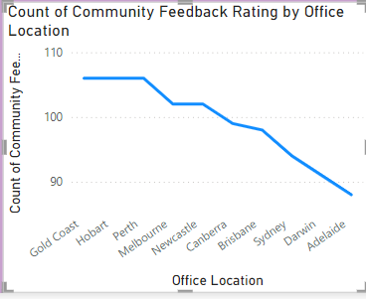

The review of Ratings given by the Community
Feedback Rating Trend:
The chart shows a descending order of the ratings in terms of community feedback from Gold Coast to Adelaide.
Of all the geographic locations Gold Coast comes out as the area with the highest total count of feedback ratings of about 110, implying high satisfaction or participation among the community.
The rating count is progressively reduce across other places and Adelaide recorded the least rating count below ninety.

Office Location Insights:
Top-Rated Locations: Gold Coast and Hobart received relatively high feedback ratings implying that these offices are well seen by the community. Positive scores may stem from efficient services or sound relationship with an organization’s community.
Mid-Rated Locations: Some cities like Perth, Melbourne and Newcastle are in this category with moderate community satisfaction.
Low-Rated Locations: Brisbane, Sydney, Darwin, and Adelaide have lower feedback scores than the other states with Adelaide having the lowest feedback scores. This pose the possibilities of challenges in these offices may be in customer services, responsiveness, or in engaging communities.

Key Insights
High Community Satisfaction:

Gold Coast office and Hobart office, where feedback volumes are high, reveal high level of community contribution or servicefulness. It is could be a possibility that some of these locations are having adopted practices that can be aligned to other offices.

Need for Improvement in Low-Rated Offices:
Offices such as Adelaide and Darwin have relatively lower ratings and that means their social responsiveness or customer service can still be improved. It may be done to solve certain issues within the interest and concern of a community or to enhance delivery of services.

Benchmarking Best Practices:
The best practices identified within high satisfaction locations could be applied within mid- and low-satisfaction offices in order to potentially improve community satisfaction at these less popular locations.

Key Insight

Offices suggested to be shut down or have reduced staff consist of

Adelaide:
Justification: Adelaide has the lowest compliance rate (818.18%) and the poorest result in community feedback (88), together with low usage of equipment and poor reception of incentives. This office could be downsized while only slightly compromising the subject’s compliance and ability to serve the community.
Recommendation: Maybe it is time to shutdown or at least minimize the operation of the business. Move representatives from poorly performing offices to better offices or locations which are more important for the company.

Darwin:
Justification: Darwin has average compliance but the community feedback which is totally low and least usage of equipment. While incentives are neither firmly rewarded nor firmly punished, the overall performance is low to moderate.
Recommendation: It may be logical to draw less resources and employees in this office, or to cut certain low activity types or consider merging its functions with those of other offices.

Melbourne:
Justification: Melbourne has average ratings on all the metrics, and it does not mean that it deserved to retain to the existing resource allocation as it being compared with better offices like Hobart and Canberra.
Recommendation: Think in terms of moderate reduction in staffing and concentrate on the best way of redistributing resources to the areas that may benefit from them most. It is crucial to keep only a minimum of human resource comprising of only permanent employees and key infrastructure that is relevant to Melbourne’s fundamental tasks.

Choice of the Offices to be Retained with an Emphasis of Performance Improvement

Brisbane and Sydney:
Justification: The insights revealed moderately satisfactory performance in all benchmark categories for both offices; however, since both are placed in prime locations, it would be mutually advantageous to continue to operate these offices while focusing on the efforts to increase engagement with the community and enhance compliance.
Recommendation: It is possible to tailor resources in order to positively affect these offices, especially in terms of Community engagement and compliance to bring these offices towards the performances of the best offices.

Newcastle:
Justification: Newcastle has high equipment usage for soils and soil quality tests and moderate interaction from the community. On the one hand, compliance might be better improved, but it is still useful for regional monitoring due to equipment specialization.
Recommendation: Grow Newcastle continuing to concentrate on developing compliance and a better response from the community.

High-Performing Offices

Hobart, Canberra, and Gold Coast:
Justification: They possess high performance levels in Terms of Operational Compliance, Community Feedback, and Resource Exploitation which makes them equally significant for upholding of standards across organizations.

